**DAILY ONLINE ACTIVITIES SUMMARY**

|  |  |  |  |  |  |  |  |  |
| --- | --- | --- | --- | --- | --- | --- | --- | --- |
| **Date:** | **21/06/2020** | | | | | **Name:** | **Shwetha** | |
| **Sem & Sec** | **8th B** | | | | | **USN:** | **4AL16CS101** | |
| **Online Test Summary** | | | | | | | | |
| **Subject** | | **-** | | | | | | |
| **Max. Marks** | | **-** | | **Score** | | | **-** | |
| **Certification Course Summary** | | | | | | | | |
| **Course** | **Artificial intelligence in python** | | | | | | | |
| **Certificate Provider** | | | **Great learning** | | **Duration** | | | **7hr** |
| **Coding Challenges** | | | | | | | | |
| **Problem Statement:**  **C Program to Find Transpose of a Matrix.** | | | | | | | | |
| **Status: Solved**  **Solution link: https://github.com/alvas-education-foundation/Shwetha-** | | | | | | | | |
| **Uploaded the report in Github** | | | | | **Yes** | | | |
| **If yes Repository name** | | | | | **Shwetha-** | | | |
| **Uploaded the report in slack** | | | | | **Yes** | | | |

Certification Course Details:

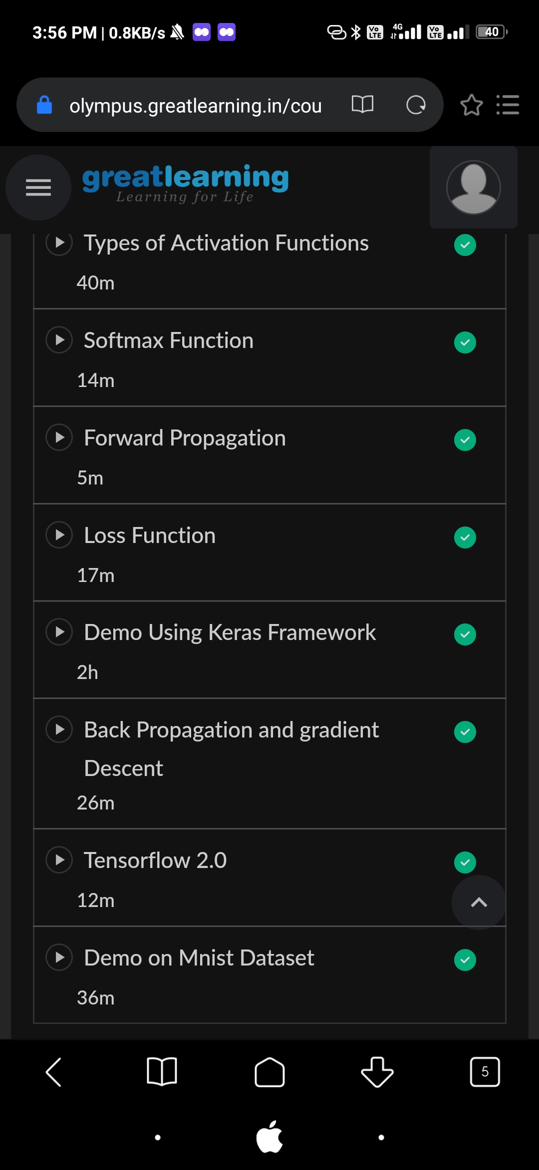

*Coding Challenges Details:*

#include <stdio.h>

int main() {

int a[10][10], transpose[10][10], r, c, i, j;

printf("Enter rows and columns: ");

scanf("%d %d", &r, &c);

// Assigning elements to the matrix

printf("\nEnter matrix elements:\n");

for (i = 0; i < r; ++i)

for (j = 0; j < c; ++j) {

printf("Enter element a%d%d: ", i + 1, j + 1);

scanf("%d", &a[i][j]);

}

// Displaying the matrix a[][]

printf("\nEntered matrix: \n");

for (i = 0; i < r; ++i)

for (j = 0; j < c; ++j) {

printf("%d ", a[i][j]);

if (j == c - 1)

printf("\n");

}

// Finding the transpose of matrix a

for (i = 0; i < r; ++i)

for (j = 0; j < c; ++j) {

transpose[j][i] = a[i][j];

}

// Displaying the transpose of matrix a

printf("\nTranspose of the matrix:\n");

for (i = 0; i < c; ++i)

for (j = 0; j < r; ++j) {

printf("%d ", transpose[i][j]);

if (j == r - 1)

printf("\n");

}

return 0;

}